Quick Guide: LIsten live for public Sittings


EARLY MORNING, THE DAY OF the sitting
(1) Tweet via Tynwaldinfo Twitter account,
then retweet via Tynwaldlive Twitter account:

(2) Set an alarm/reminder to alert you to when to switch on the live streaming.

HALF AN HOUR before the sitting
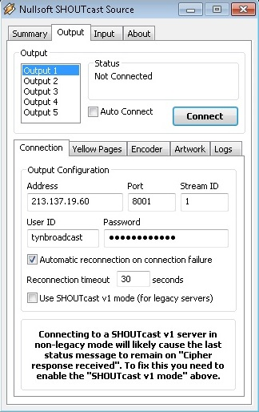
(1) Open the Remote Desktop Connection to the relevant Shoutcast PC:
House of Keys Chamber: public.tynwald.org.im:3390
Tynwald Chamber: public.tynwald.org.im:3391
LegCo Chamber: public.tynwald.org.im:3392
(2) Open Winamp software
(3) Select the correct Output: Output 1 = Tynwald
Output 2 = House of Keys
Output 3 = Legislative Council
Output 4 = Committees

Two minutes before the sitting
[HAvE AN ALARM SET!]
(1) Click Connect to start Live Streaming
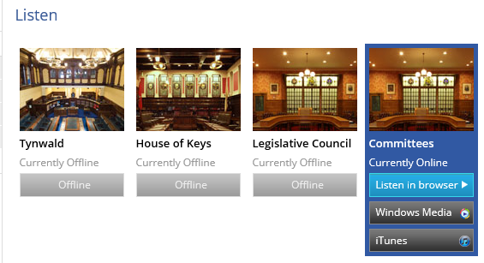
(2) Refresh the Listen Live webpage to ensure the system is live:

DURING the sitting
Listen to the start of the hearing to ensure the audio is live streaming correctly.

At the end of the sitting
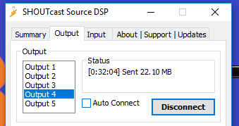
(1) Click Disconnect to stop Live Streaming and close Winamp

(2) Sign out of Shoutcast PC [DO NOT switch off the machine!]

